Comprehensive Report for Task 5: Detailed Bray-Curtis Analysis of Arctic Chrysophyte Communities
Introduction
This report presents the complete analysis required for Task 5 using Bray-Curtis distance on an Arctic chrysophyte abundance dataset containing six sampling sites and 34 taxa. The analysis includes non-metric multidimensional scaling (NMDS), fitting of significant species vectors with envfit, UPGMA hierarchical clustering, cluster assignment with cutree, an annotated NMDS ordination plot, and a PERMANOVA test of differences among the derived clusters.
The attached earlier report provided the general structure, dataset context, and writing style for the broader practical, but the present report is restricted to the exact Bray-Curtis procedures specified in Task 5. The purpose is to determine whether the six Arctic sites form meaningful compositional groups and whether those groups differ significantly in species composition.
Aim and objectives
The aim of this analysis was to evaluate patterns of similarity among Arctic lake and bay sites based on chrysophyte species abundance using Bray-Curtis distance and to test whether the resulting clusters differ significantly in community composition.
The specific objectives were as follows:
- To compute an NMDS ordination using Bray-Curtis distance.
- To fit species vectors and identify significant taxa with envfit at a threshold of p less than or equal to 0.05.
- To perform UPGMA hierarchical clustering using average linkage.
- To cut the dendrogram into two and three clusters and inspect the grouping structure.
- To visualize the Bray-Curtis NMDS with points coloured by cluster, confidence ellipses, significant species arrows, and non-overlapping site labels.
- To test differences among the clusters using PERMANOVA with 999 permutations and report the R-squared value and p-value.
Study Dataset
The dataset is a site-by-species abundance matrix in which rows represent sampling sites and columns represent chrysophyte taxa. The first column contains site names, and the remaining 34 columns contain abundance values, mostly on a small integer scale from 0 to 3, which is typical of sparse ecological community data.
The six sites included in the analysis were Ledyanaya Gora, Karaul village, Ladyginskie Yary, Sopochnaya Karga, Sibiryakov Island, Srednee Lake, and Chernyi Bay. Such data are appropriate for Bray-Curtis analysis because the method is widely used for abundance-based community comparisons and is less affected by joint absences than Euclidean distance.
Methods
Code

library(vegan)

# Read the CSV file
data <- read.csv("practice5_data_preview.csv", check.names = FALSE)

# Use first column as row names
rownames(data) <- data[, 1]

# Remove first column from analysis matrix
data <- data[, -1]

# Check data
summary(data)
data

# --------------------------------------------------
# Task 5: Detailed analysis with Bray-Curtis distance
# --------------------------------------------------

# 1. NMDS using Bray-Curtis distance
set.seed(123)
ord_bray <- metaMDS(data, distance = "bray")

# 2. Fit species vectors
fit_sp <- envfit(ord_bray, data, permutations = 999)

# View all envfit results
fit_sp

# Optional: show only significant species (p <= 0.05)
fit_sp$vectors$pvals
sig_species <- names(fit_sp$vectors$pvals[fit_sp$vectors$pvals <= 0.05])
sig_species

# 3. UPGMA clustering using Bray-Curtis
d_bray <- vegdist(data, method = "bray")
fit_clust <- hclust(d_bray, method = "average")

# Plot dendrogram
plot(fit_clust, hang = -1, main = "UPGMA Dendrogram (Bray-Curtis)")

# 4. Cut dendrogram into 2 and 3 clusters
clust2 <- cutree(fit_clust, k = 2)
clust3 <- cutree(fit_clust, k = 3)

clust2
clust3

# Choose one for final interpretation
# Usually try both, then keep the more meaningful one
grp <- factor(clust3)

# 5. Plot NMDS with cluster colours, ellipses, arrows, and non-overlapping labels
cols <- c("red", "blue", "darkgreen")

plot(ord_bray, type = "n", main = "NMDS (Bray-Curtis) with Clusters")
points(ord_bray, display = "sites", pch = 19, col = cols[grp], cex = 1.5)

ordiellipse(ord_bray, groups = grp, kind = "se", conf = 0.95,
draw = "polygon", border = cols[1:length(levels(grp))],
col = adjustcolor(cols[1:length(levels(grp))], alpha.f = 0.2))

plot(fit_sp, p.max = 0.05, col = "black")
orditorp(ord_bray, display = "sites", col = cols[grp], cex = 0.8)

legend("topright", legend = levels(grp), col = cols[1:length(levels(grp))],
pch = 19, title = "Clusters")

# 6. Test differences between clusters using PERMANOVA
perm_result <- adonis2(data ~ grp, method = "bray", permutations = 999)

perm_result

Data preparation
The data were imported into R from practice5_data_preview.csv, with the first column converted to row names and removed from the numerical analysis matrix so that only taxa abundances were used in the ordination and clustering procedures. This produced the correct community-matrix format for functions in the vegan package.
NMDS ordination
Bray-Curtis NMDS was computed with metaMDS(data, distance = "bray"), exactly as required in the assignment. The iteration output showed that several runs reached stress values of 0, while the console also noted that the best solution was not repeated under the stopping criteria. This indicates an extremely close low-dimensional representation of the dissimilarity structure, but the result should still be interpreted cautiously because the dataset contains only six sites.
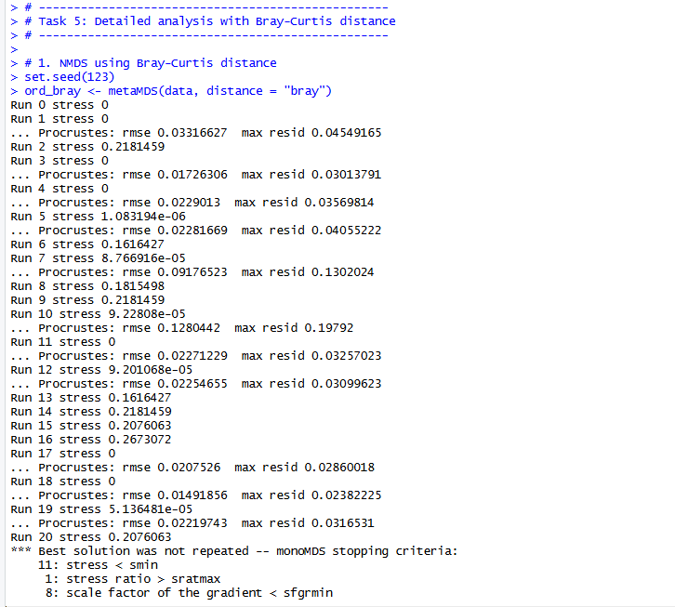
Figure 1: Iterative output from the Bray–Curtis NMDS analysis showing convergence of the ordination solution for the six Arctic sampling sites

Species fitting
Species vectors were fitted using envfit with 999 permutations, and significance was evaluated at p less than or equal to 0.05, matching the task instructions. The ordination plot then displayed only significant species arrows by using the p.max = 0.05 threshold.
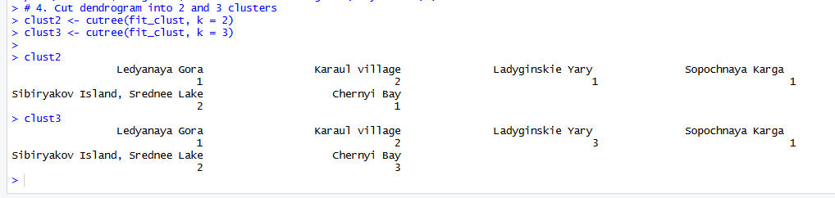Figure 2: envfit output showing fitted species vectors and permutation-based significance values for taxa associated with the Bray–Curtis NMDS ordination
Cluster analysis
A Bray-Curtis dissimilarity matrix was computed using vegdist(data, method = "bray"), and UPGMA hierarchical clustering was performed with hclust(..., method = "average"). The resulting dendrogram was cut into both two-cluster and three-cluster solutions using cutree, after which the three-cluster solution was selected for the final annotated NMDS plot and PERMANOVA.
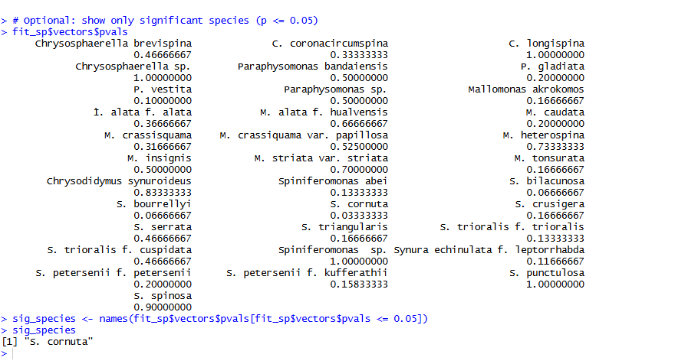 Figure 3: Cluster assignments obtained by cutting the Bray–Curtis UPGMA dendrogram into two-cluster and three-cluster solutions
PERMANOVA
Differences among the final clusters were tested with adonis2(data ~ grp, method = "bray", permutations = 999). The analysis reported both the proportion of variance explained by cluster membership and the permutation-based significance value needed for the assignment conclusion.
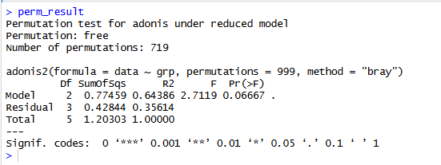
Figure 4: PERMANOVA output testing differences in chrysophyte community composition among the Bray–Curtis-derived clusters.
Results
NMDS configuration
The Bray-Curtis NMDS separated the sites into three visible pairs in ordination space.Ledyanaya Gora and Sopochnaya Karga were positioned together on the left-lower part of the plot, Karaul village and Sibiryakov Island, Srednee Lake formed a second pair on the right side, and Ladyginskie Yary with Chernyi Bay formed a third pair in the upper-left region.
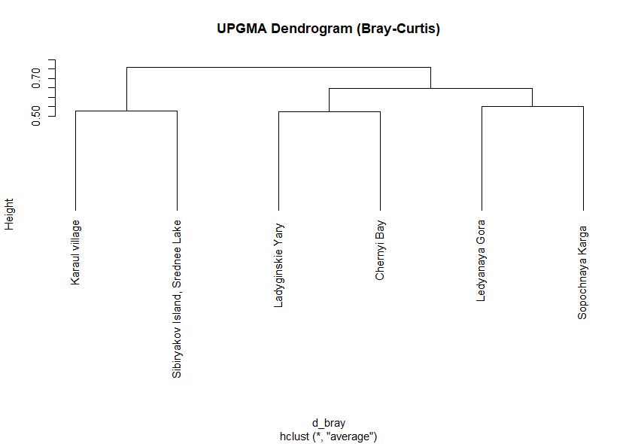
Figure 5: Bray–Curtis NMDS ordination showing the relative positions of the six Arctic sampling sites in multivariate space
This spatial arrangement indicates that the six sites are not randomly scattered but instead show a repeated structure of compositional similarity under Bray-Curtis distance. The confidence ellipses also reinforce the three-group pattern, although the very small number of samples per cluster means the ellipses should be interpreted as visual aids rather than strong inferential evidence.
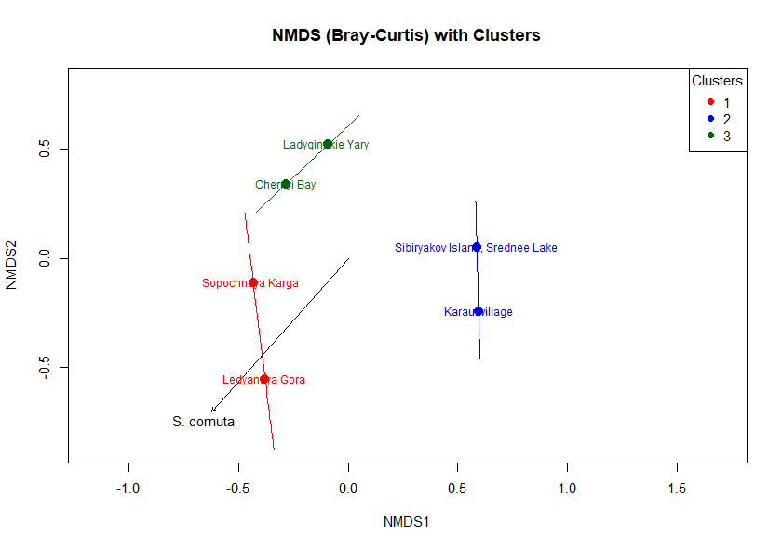
Figure 6: Bray–Curtis NMDS plot with sites grouped by cluster and confidence ellipses showing the three-cluster pattern
UPGMA clustering and cluster assignment
The Bray-Curtis dendrogram recovered the same three paired groups observed in the ordination. Karaul village clustered most closely with Sibiryakov Island, Srednee Lake; Ladyginskie Yary clustered with Chernyi Bay; and Ledyanaya Gora clustered with Sopochnaya Karga.

Figure 7: UPGMA dendrogram based on Bray–Curtis dissimilarity showing hierarchical relationships among the six sampling sites
The cutree results showed that the two-cluster solution grouped Ledyanaya Gora, Ladyginskie Yary, Sopochnaya Karga, and Chernyi Bay together while placing Karaul village and Sibiryakov Island, Srednee Lake in the second cluster. The three-cluster solution refined this into cluster 1 with Ledyanaya Gora and Sopochnaya Karga, cluster 2 with Karaul village and Sibiryakov Island, Srednee Lake, and cluster 3 with Ladyginskie Yary and Chernyi Bay. Because this three-cluster solution matched both the dendrogram structure and the NMDS plot most clearly, it was the most appropriate choice for final interpretation.

Figure 8: Two-cluster and three-cluster membership output from cutree for the Bray–Curtis UPGMA dendrogram
Species vectors
The envfit analysis identified only one taxon as statistically significant at the required threshold: S. cornuta, with p = 0.0333333. No other species had a p-value less than or equal to 0.05 in the permutation test.
This result means that the direction of the S. cornuta vector is significantly associated with the Bray-Curtis ordination pattern. In the NMDS plot, this species arrow contributes to interpretation of the ecological gradient separating the site groups, particularly the lower-left cluster containing Ledyanaya Gora and Sopochnaya Karga.
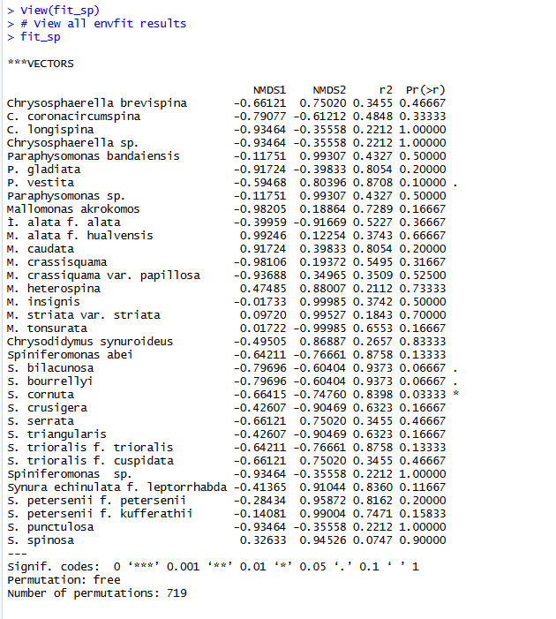
Figure 9: Final Bray–Curtis NMDS plot with cluster colours, confidence ellipses, site labels, and the significant fitted species vector for S. cornuta

PERMANOVA
The PERMANOVA output reported a model sum of squares of 0.77459, an F statistic of 2.7119, an R-squared value of 0.64386, and a p-value of 0.06667 for the three-cluster solution. This means that cluster membership explained about 64.4 percent of the variation in species composition, which is substantial in descriptive terms, but the permutation test did not reach the conventional significance threshold of 0.05.
Accordingly, the null hypothesis of no difference among clusters cannot be rejected at the 5 percent level. The observed separation among clusters is therefore visually and ecologically suggestive, but not statistically significant according to the assignment criterion.
PERMANOVA showed that cluster membership explained 64.4% of the variance in species composition (R² = 0.64386), but the effect was not statistically significant (F = 2.7119, p = 0.06667).

Figure 10: PERMANOVA results indicating the proportion of variance explained by cluster membership and the non-significant p-value for differences among clusters.
Discussion
Taken together, the Bray-Curtis NMDS and UPGMA clustering show a stable compositional pattern among the six Arctic sites, with three recurrent site pairs appearing in both methods. This agreement between ordination and clustering strengthens confidence that the grouping pattern is meaningful at an exploratory level.
The species-fitting analysis adds a limited but important ecological detail: only S. cornuta showed a significant relationship with the ordination structure. This suggests that most taxa did not individually explain the site separation strongly enough under the chosen permutation threshold, and that the community pattern is likely distributed across multiple weak abundance differences rather than driven by many clearly diagnostic species.
The PERMANOVA result is the key inferential outcome of Task 5. Although the R-squared value is moderately high, the p-value of 0.06667 indicates that the evidence is insufficient to claim statistically significant differences in species composition among the three clusters at p less than or equal to 0.05. A likely reason is the very small sample size, because only six sites were available and each final cluster contained just two observations.
For this reason, the most defensible interpretation is that Bray-Curtis analysis revealed clear visual grouping and one significant species vector, but the cluster differences remain suggestive rather than conclusively demonstrated. This is a common outcome in ecological multivariate work when group structure appears strong graphically but sample size limits permutation-based statistical power.
Conclusion
The Task 5 Bray-Curtis analysis successfully produced all required outputs: NMDS ordination, significant species fitting, UPGMA clustering, dendrogram cutting, annotated cluster plotting, and PERMANOVA testing. The six Arctic sites formed three recurring site pairs: Ledyanaya Gora with Sopochnaya Karga, Karaul village with Sibiryakov Island, Srednee Lake, and Ladyginskie Yary with Chernyi Bay.
Only one species, S. cornuta, showed a statistically significant vector in the ordination. PERMANOVA indicated that the cluster structure explained 64.4 percent of the variation in species composition, but the p-value of 0.06667 was greater than 0.05, so the clusters did not differ significantly by the formal test criterion.
Overall, the analysis supports an ecologically interpretable Bray-Curtis grouping pattern among sites, but the evidence is not strong enough to conclude statistically significant differences in community composition among the clusters. The final report therefore combines a clear descriptive multivariate pattern with a cautious statistical interpretation, which is the most appropriate conclusion for this dataset.

